

Faculty: How to submit items in CloudCME

Go to: https://uva.cloud-cme.com/default.aspx

The Faculty section in the blue banner enables faculty, planners, and peer reviewers to manage system and activity tasks. Peer reviewers can also initiate the peer review process from this area.

Respective areas will have a red circle with a number indicating a requested action. When an action is requested, faculty will receive an automated email from University of Virginia Continuing Education at uvace@uva.cloud-cme.com

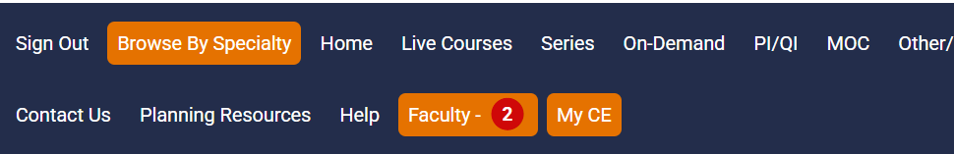
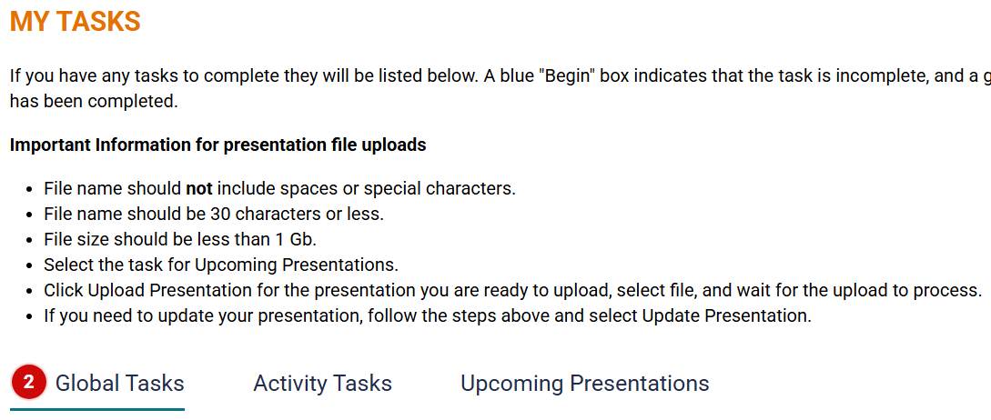

The Global Tasks area displays assigned system tasks such as uploading a photo, a CV, or submitting/updating a disclosure. Click on the ‘begin’ or ‘update’ button to start.

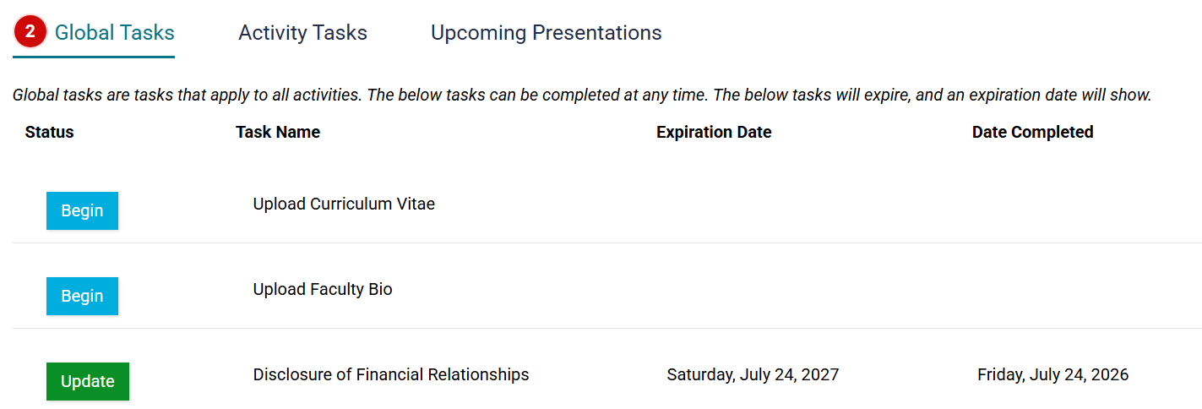

**Disclosure forms can also be completed by using this direct link: https://uva.cloud-cme.com/disclosure.aspx

The Activity Tasks area displays assigned activity tasks such as release forms and availability. Click on the ‘begin’ or ‘update’ button to start.

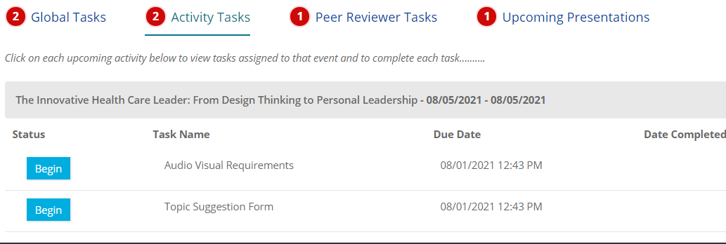
The Peer Reviewer Tasks area allows peer reviewers to begin the peer review process. Peer reviewers can download presentations, view disclosure forms, submit suggested revisions, and approve/reject presentations from this screen.

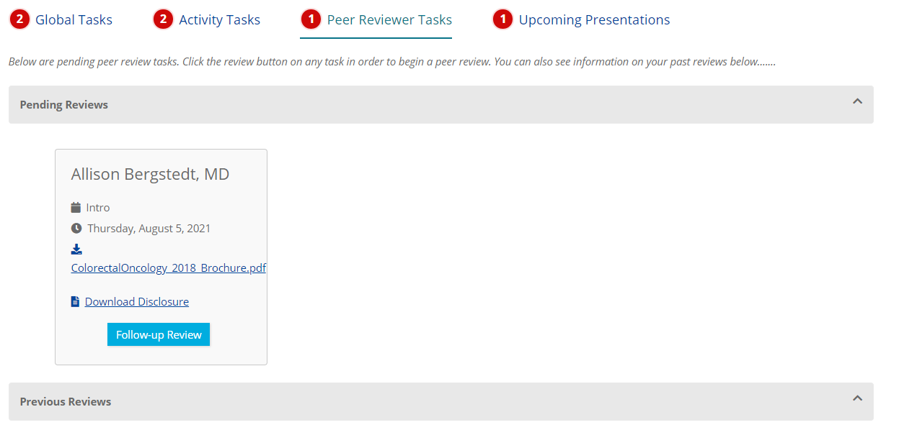

The Upcoming Presentations area displays assigned presentation tasks for specific activities. Users can upload presentations, view requested revisions, and upload revised presentations from this screen.

